**Answers**

**GIT:**

Gitlab Runners:

A GitLab runner is a lightweight, highly-scalable agent that picks up a CI job, runs the job as outlined in the pipeline configuration file, and sends the result back to the GitLab instance.

Release branch:

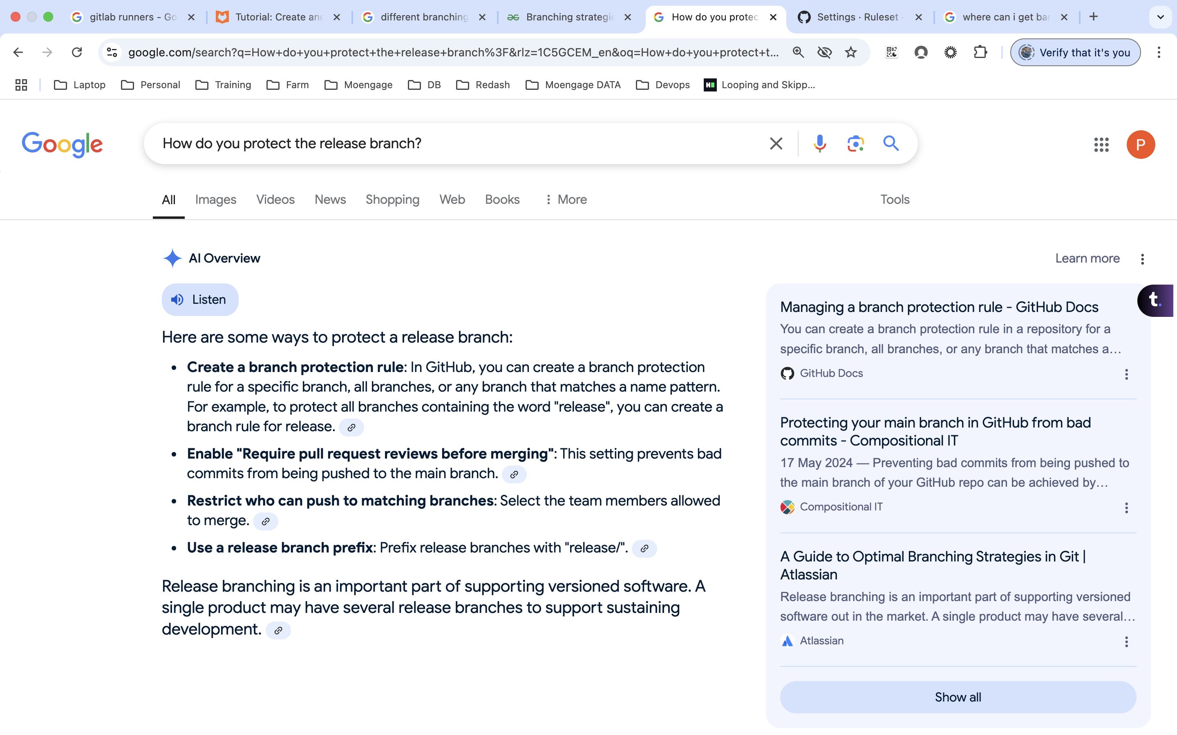

Hotfix:

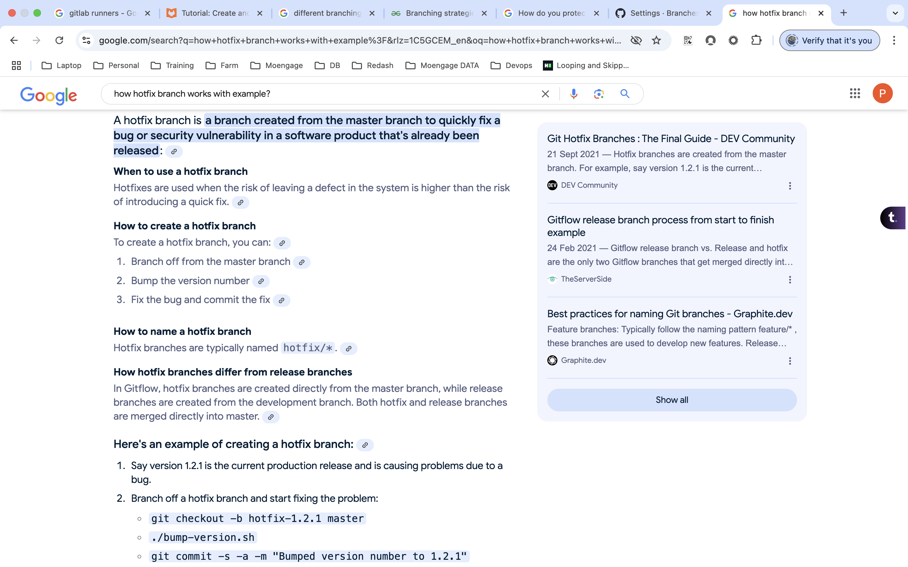

Branching Strategy:  
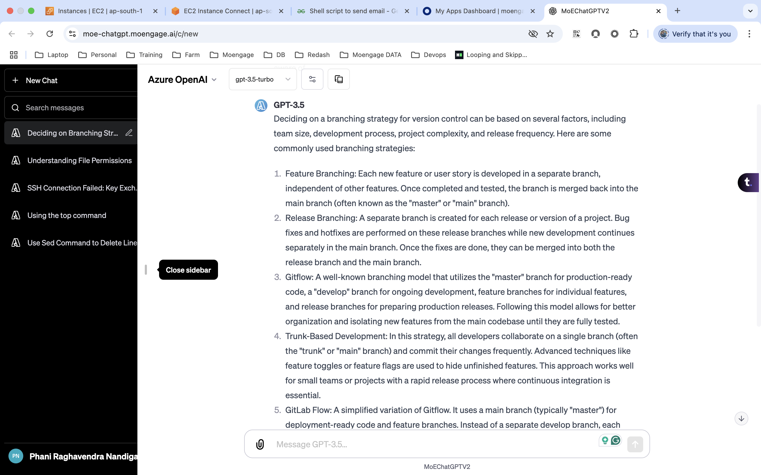

PR:

